Streetscape Analysis of Halifax North End

Streets within the North End Business Improvement District (BID)

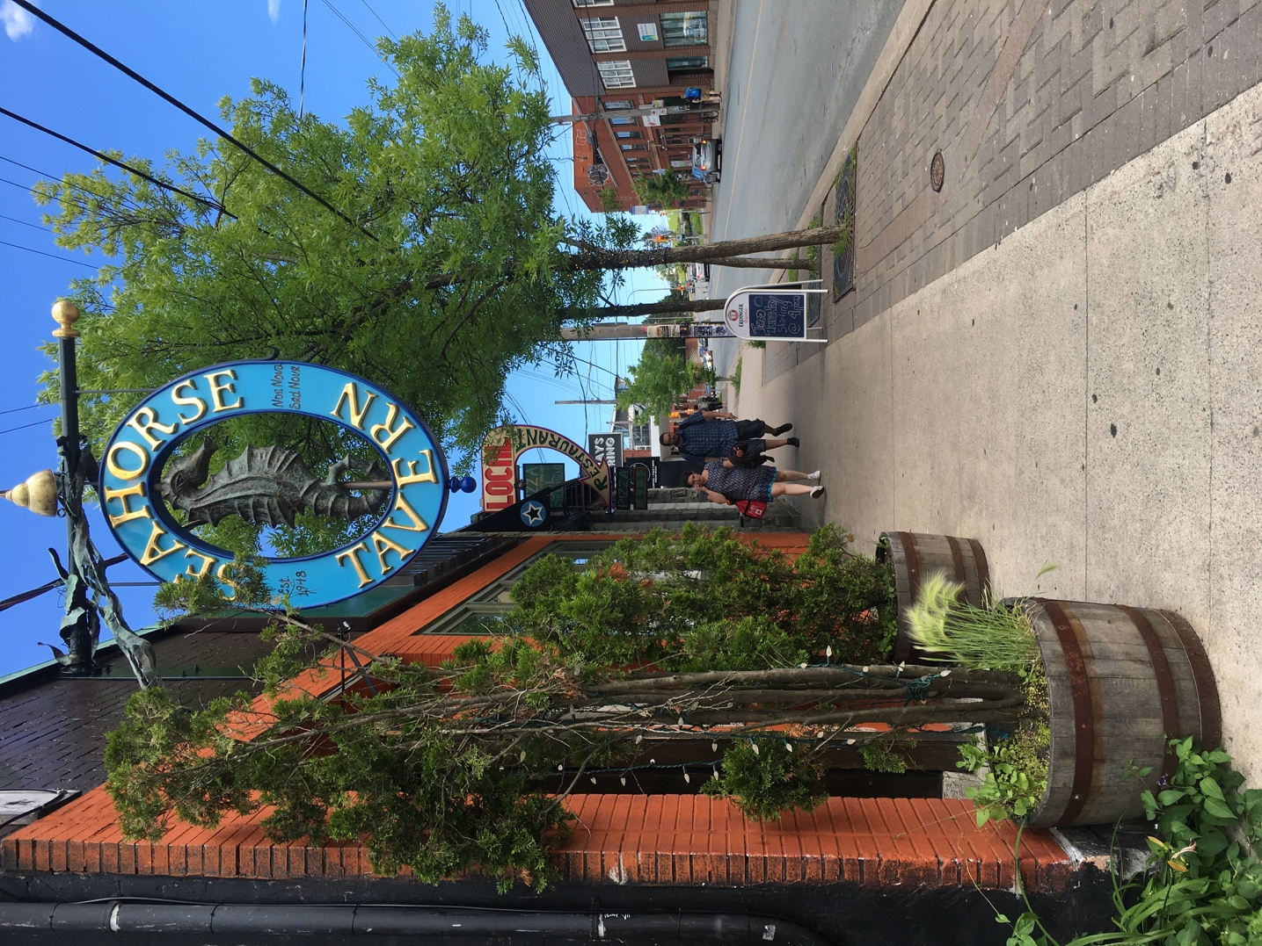

By: Jiajing Chen

Intent of the report
The report provides a brief introduction of North End BID streetscape typologies, and the Strength, Weakness, Opportunities, and Threats (SWOT) analysis for representative streets. It includes planning principles and recommendations to shape the preliminary design of the streetscape, transit facilities and other urban design components of the Agricola Street Enhancement (ASE) project. The goal is to support the creation of a safe, vibrant, sustainable, and pedestrian-friendly environment within the District.

Introduction to North End
North End Halifax was once the city’s economic hub. At one point, Gottingen Street was the busiest shopping and theatre district in Halifax. However, the 1917’s Halifax Explosion changed everything. After losing their homes, churches and businesses, the north end population rebuilt itself. Presently, the north end is in the midst of a renaissance (North End Business Association, 2017).
The Streetscape of North End has changed a lot since that time. Now, Gottingen Street, the commercial and entertainment heart of the North End, is more than 250 years old. Gottingen Street is home to numerous shops, bars, clubs, and performance venues. It contains a wide variety of buildings ranging from one to eight storeys with its own unique look and feel. Agricola Street, which runs parallel to Gottingen Street, is another commercial district home to many local shops, restaurants, and galleries. It is a vibrant mixed-use corridor housing an eclectic mix of commercial, residential, and institutional uses.
Established in 2011, the North End BID is an assessment district where business people join together to promote and improve the economic vitality of the area (Figure 1). It is an urban area with over 25 streets (Figure 1). The land area of North End BID is around 0.61 square kilometres with an upward trend of overall population in the province (Statistics Canada, 2012).

Figure 1. North End BID. Map from: NEBA website.
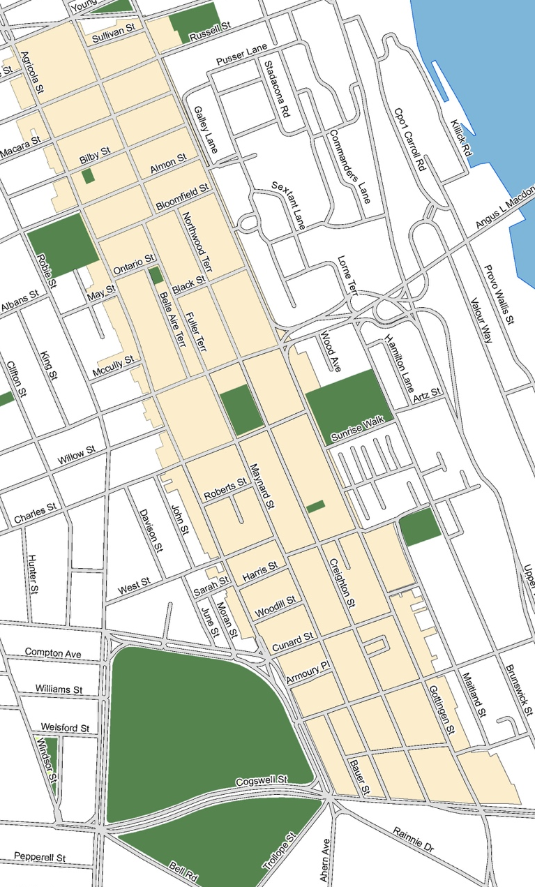
Within the past year however, there has been increased interest in developing a report for the streetscape within the District to guide future public realm initiatives related to infrastructure upgrades. Agricola Street is designated as the potential street repaving area next year by the Halifax Regional Municipality (HRM). North End Business Association (NEBA) and Halifax Cycling Coalition (HCC) held a workshop featuring Gary Toth to discuss the the key elements that shape the Agricola Street right-a-way. It brought together a dedicated group of stakeholders including representatives of HRM, HCC, NEBA, Agricola Street businesses, and local residents. HRM and NEBA have devoted much attention to the ASE project and the North End BID streetscape.

Recent documents referencing streetscapes

3.1 Integrated Mobility Plan (IMP)
HRM’s vision for the IMP is that an appropriate mix of roadways, public and community based transit networks, and land uses can create a system that establishes a street hierarchy that supports adjacent building uses and growth centres (HRM, 2017a). Recognizing that North End is still vehicle oriented, HRM respects the current road network and is searching for an integrated approach for the area. Started in 2016, IMP would provide a choice of integrated and connected travel options (HRM, 2017).
Check more information online at www.halifax.ca/integratedmobility.

Centre Plan
Working within the framework of the 2017 Centre Plan, complete streets in communities will be created to meet the needs of all ages (HRM, 2017b). Acknowledging what will change, and respecting what will remain the same in the Gottingen Street Centre and Agricola Street Corridor, the growth should respect the historic character of the area and contribute it as an “inclusive and diverse urban village” (HRM, 2017b).
Check more information online at http://centreplan.ca.

5 Year, $50 Million Capital Improvement Campaign Council Report
In 2014, HRM approved a decision-making matrix in the 5 Year, $50 Million Capital Improvement Campaign report (HRM, 2014a). The matrix sets out criteria to assess and give priority to urban core public realm improvements projects between 2014/15 and 2018/19 (HRM, 2014a). Gottingen Street was identified as an eclectic local service centre, so additional investments are needed to foster the area. The matrix gave Gottingen Street project a low score, however, Gottingen streets has been developed fast in recent years. The report’s policy background and scoring standard should be updated.
Check more information online at https://drive.google.com/file/d/0BzwirXpB6w91SHNBcTBxY18taDhKaVlIZUZoOTk2dGlSbkNj/view?usp=sharing.

4. Understanding North End BID Streetscape
Average assessed commercial property values increased in all of peninsular Halifax’s main business districts since 2011: 16% on Spring Garden Road, 12% on Quinpool Road, and 17% in the North End (Bundale, 2012). The community experiences an increasing interest in commercial development, especially in local and small business. A modest recovery is occurring for the North End (Roth, 2013). Many cities in North America and beyond had converted to a grid system, or were at least designing new city streets to suit this pattern. This is why we see the crisscross street patterns of today (Figure 2).
Figure 2. North End BID grid street pattern. Image from: Mapbox.
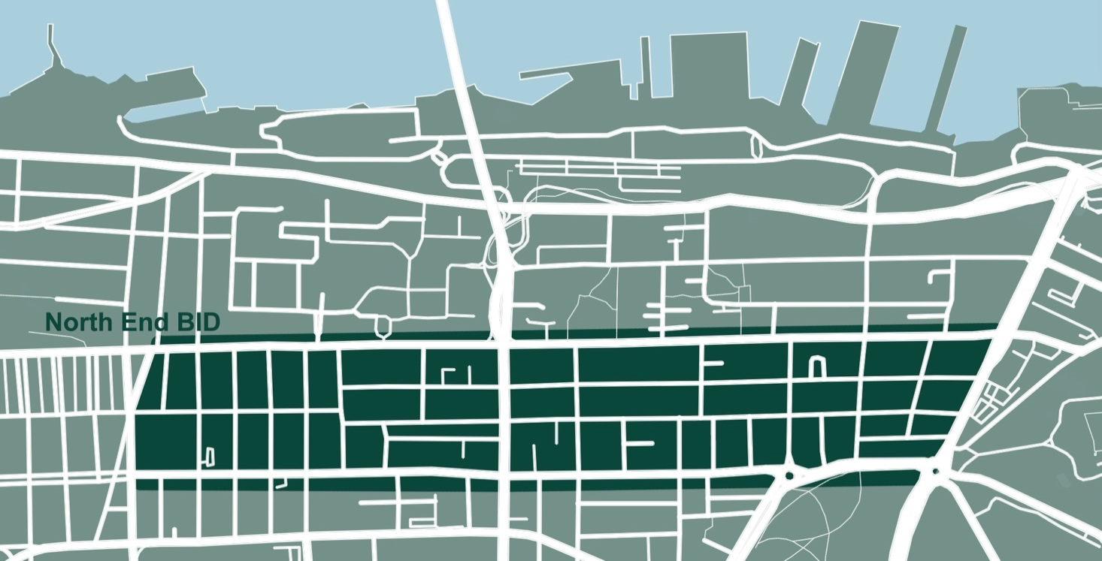
While studying maps and images of the area, I noticed that the study site has few street trees, which may be due to the historic use of wood for residential construction and/or the combination of sidewalk dimensions and minimal to no building setbacks. Regardless, there are several commercial sections on the Agricola Street and Gottingen Streets that contains no public trees, except in designated parks. During visits to the residential areas of the BID, a noticeable increase in the number of streets containing public trees became apparent. However, these trees were not very large (old growth) and a lot of trees in the area were privately owned and maintained.

Street Typology
The street typologies in this report are classified by land use and transportation characteristics. As described by the San Francisco Planning Department (SFPD), street Types are not necessarily continuous along the entire length of a street; a single street may change typology as the surrounding land uses or functions of the road changes (SFPD, 2010).
Street Typology is defined as a guide for designing appropriate streetscape environments (SFPD, 2010). Good street design begins with an understanding of the street context. Street designs and streetscape projects must support North End’s economy and local businesses. The following section illustrates the different streetscape typologies for the North End BID, providing descriptions of their features as well as a set of recommendations and guidelines designed to capitalize on the unique character of each area while complementing the overall strategy for the entire streetscape.

Classification
In the section, Information were gathered through researches and site visits. Based on The Cardinal Streetscape Plan (2012), drawings were developed in Appendix A to demonstrate each typology. Table 1 illustrates the brief classification of the North End BID’s streetscape typologies. Centre Plan Designation was developed on the basis of the Urban Structure Map which can be found in Appendix B. The streetscape typologies would recommend an appropriate interface with existing and adjacent land uses seeking to maximize the potentials of each individual character area.
Table 1. Streetscape Typologies classification within the North End BID.
Street Name | Centre Plan  Designation | Typology | Characteristics
1. Gottingen St | Centre | Commercial Streetscape | - main vehicular routes through the area  - requiring wayfinding signs to introduce gateways into the North End and to provide a more attractive route  - 2-3 storeys structures with commercial uses sited at street level and residential apartments or offices on the upper level(s)  - Primarily two lanes of traffic (one in each direction) and on-street parking is provided on either one or both sides of the street
2. Agricola St | Corridor
3. Cornwallis St | Established  Residential  (ER)
4. Cunard St | Corridor
5. Young St | Corridor | Mixed-use Streetscape | - a mix of commercial and residential, or industrial and residential land uses  - provide secondary connections through the study area  - traffic volumes are moderate  - identified by the destinations, which include the library, the elementary school, open spaces, etc.  - primarily two lanes of traffic (one in each direction) with informal on-street parking
6. North St | ER
7. Almon St | ER
8. Isleville St | ER
9. Maynard St | Higher Order  Residential  (HOR)
10. Sullivan St | ER
11. Bauer St | ER | Residential Streetscape | - primarily single detached family dwellings  - relatively narrow sidewalks  - two lanes of traffic (one in each direction) and where space permits, informal on-street parking occurs along the shoulders of the roadway  - vehicular volume is generally low and slow in nature
12. Charles St | HOR
13. Falkland St | ER
14. Creighton St | HOR
15. Woodill St | ER
16. Harris St | HOR
17. Buddy Daye St | ER
18. Belle Aire Terrace | ER
19. Ontario St | ER
20. Bloomfield St | ER
21. Fuller Terrace | ER
22. Northwood Terrace | ER
23. Macara St | ER
24. Black St | ER
25. Roberts St | HOR | Industrial Streetscape | - primarily bordered by industrial lands on one side and comprised of residential properties on the other  - two lanes of traffic (one in each direction)  - Much of the traffic that travels the industrial corridors is comprised of large trucks.
26. Bilby St | ER
27. Russell St | Corridor
28. West St | HOR

SWOT analysis
This section provides a SWOT (Strengths, Weaknesses, Opportunities, and Threats) analysis and a description of the design elements for the representative streets. We can take advantages of the strengths to enhance street identity. By understanding the weaknesses of the streets, we have a clear idea of what could be improved and what should be avoided, so that we can manage and eliminate threats that would otherwise catch unawares. Opportunities and recommendations that improve safety, accessibility and comfort for pedestrians, cyclists and motorists, creating a complete street are provided in the analytical process. Streets built utilizing Complete Street principles encourage social interaction, provide a unique sense of place.

1. Gottingen Street
Gottingen Street is designated as a “Centre” in the 2017 Centre Plan. With several redevelopment projects, and development of new retail and multi-unit residential buildings, Gottingen Street centre is becoming more vibrant and diverse. It is a main commercial street in the North End BID.
S: It is a transit friendly street with well-designed bus stops and bike racks (Figure 3). In figure 3, some businesses decorate their building with plants, benches and tables, which are highly encouraged. In front of the Halifax North Memorial Library, the design with greenery and artistic sculpture is nice and attractive.
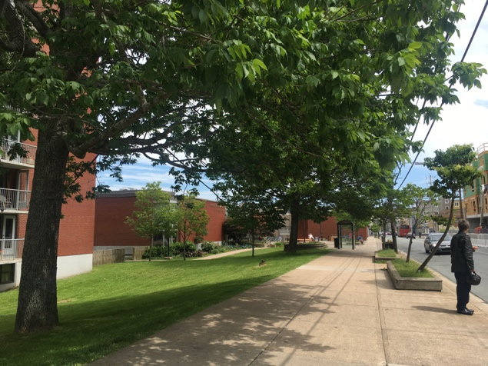
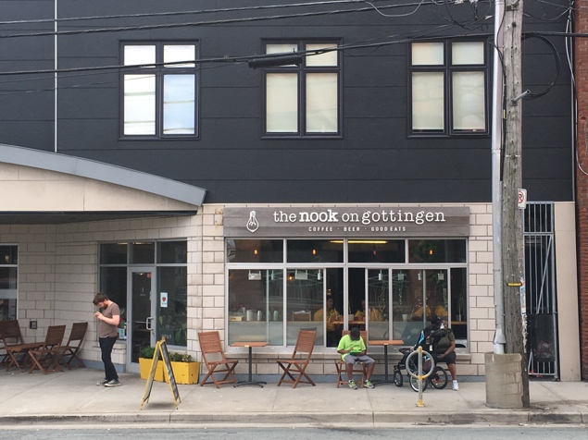
Figure 3. Street Furniture on Gottingen Street.

As shown in Figure 4, the green space at the intersection of North Street looks clean, and it has the function of calming traffic down. At one of the parking lots along Gottingen Street, a shop with special graffiti brings characteristic to the street and makes the street vibrant.

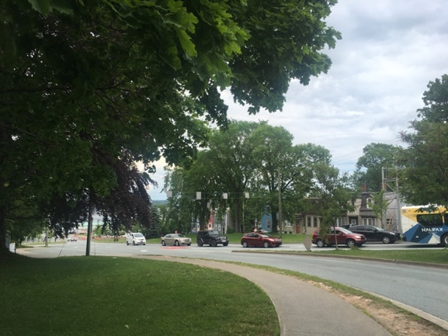
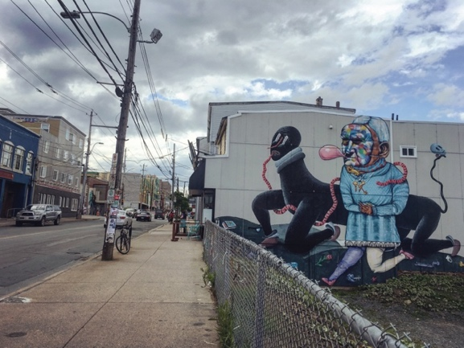
Figure 4. North Street Intersection and Graffiti on Gottingen Street.
As for building scale, at the St. Joseph’s Square building, there is no street-side walling off of the public, and the ground floor residential units and retail spaces are placed in a way that the visual lines between public and private space are blurred, and the sidewalk is welcoming (Figure 5).
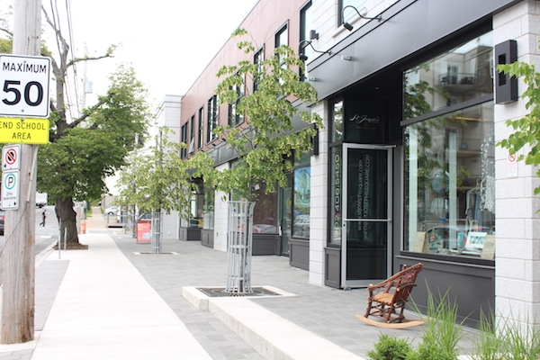
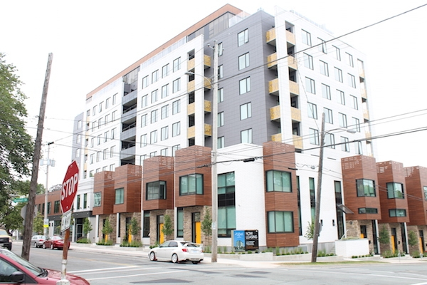
Figure 5. St. Joseph’s Square building on Gottingen Street. Image from: Halifax Examiner.
W: The entry to Gottingen Street is bald and inconspicuous.
O: As shown in Figure 6, the first crosswalk on the street is not long and the location is suited to become an attraction point. In front of the parking lot mesh, there is space for activities. The green space at the intersection of North Street is big enough to have wayfinding signs and artist sculpture to show the North End’s characters.
T: Some people are in fear of this area. Street trees are not sufficient along the street, especially the western side.
Recommendations: There could be a gateway sign at the entry of Gottingen Street to lead visitors into the area. It is recommended to decorate the first crosswalk as a street character, and to organize yarn or lock event for the parking lot mesh (Figure 6). Also, greenery along the street should be improved.
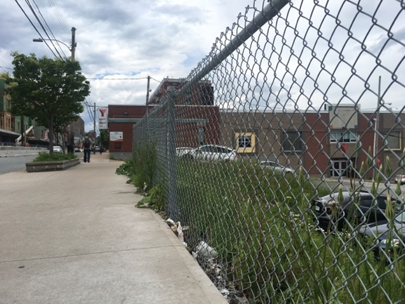
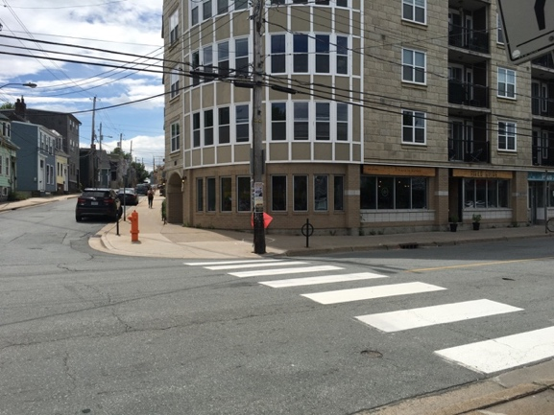
Figure 6. Gottingen Street.

2. Agricola Street
Centre Plan designates Agricola Street as a “Corridor” with the goals of strengthening it as a neighbourhood destination focus on local service, and creating a complete street with high quality streetscaping and a safe and comfortable public realm for all ages and abilities (HRM, 2017b). As recommended in the 2014-2019 Active Transportation Plan, improvements are needed to make the street more pedestrian and cyclist friendly (HRM, 2014b). NEBA has had several meetings, workshops, and concept plans put forward.
S: Some street elements provided by individual shops decorate the street well (Figure 7). It is encouraged for businesses to do that. Greenery outside the Cycle Smith is clean and beautiful (Figure 7).
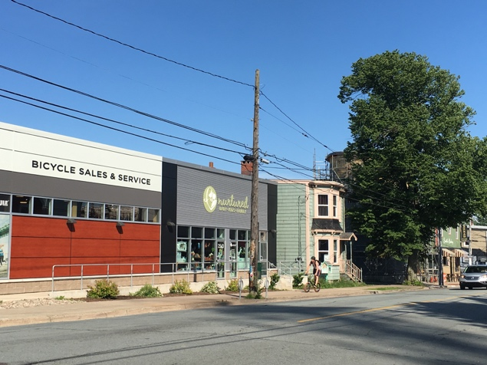
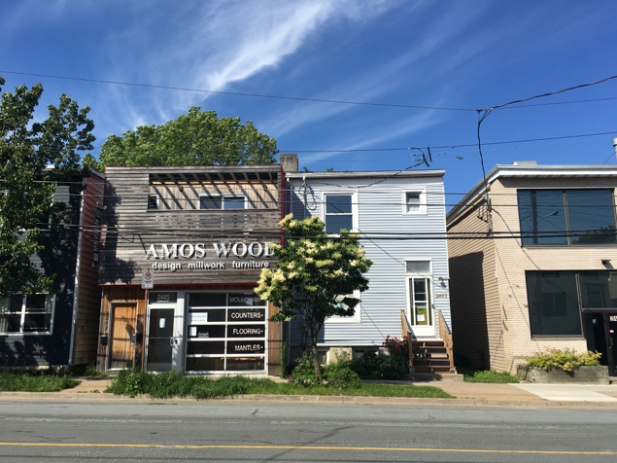
Figure 7. Street Greenery on Agricola Street.
W: Sidewalks along the street are too narrow. The residential stairs occupy a large part of the sidewalk space. At the roundabout, the sign of Agricola Street is not attractive (Figure 8). There are only few trees on the eastern side of the street (Figure 8).
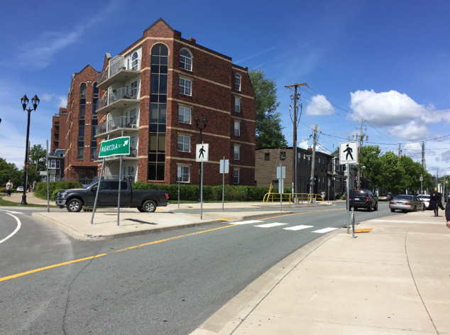
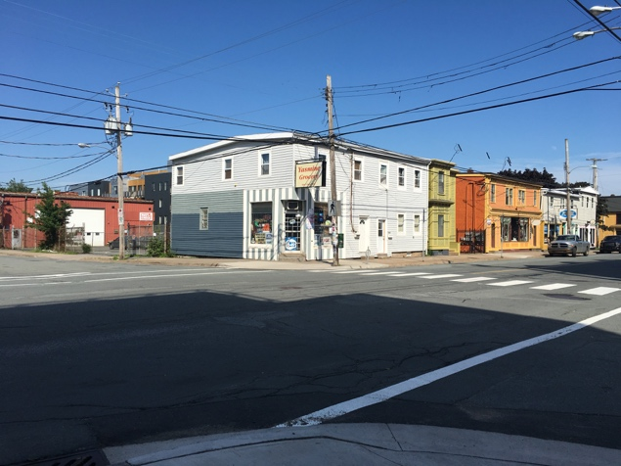
Figure 8. Agricola Street Sign and Few Trees on the Eastern Side.
O: Agricola Street re-paving is scheduled for 2018. This is a key opportunity to make improvements that will enhance the safety and attractiveness of the area.
After the roundabout crosswalks at the commons, there are four other pedestrian crossings along Agricola Street between the commons and Almon Street. They are potential curb extension areas.
As shown in Figure 9, there is a small open space at the intersection of Almon Street where could be a great spot to have a wayfinding sign.
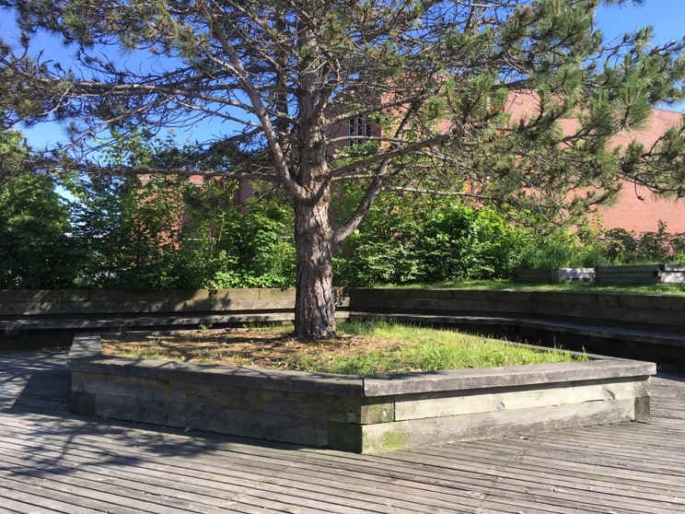
Figure 9. A Small Open Space at the Intersection of Almon Street.
T: As Evans (2017) noted, the area has seen an influx of small technology and design companies, and NEBA expect this trend to continue. These companies need parking space to accommodate clients who drive in here. This is an aspect that so far has not been considered. Evans noticed that there are no public washrooms which reflects on the incomplete governance and planning for the city as a whole (Evans, 2017).
Recommendations: Sidewalks are narrow (Figure 10). They should be widened and decorated with greenery, so that people would like to walk about along Agricola Street. It would be better to install a more inviting and well-designed gateway sign at the roundabout (Figure10). Park-style benches, associated bump-outs, and crosswalk have been installed in the roundabout areas. Evans recommended to emulate this style and provide a logical continuance on Agricola Street (Evans, 2017).
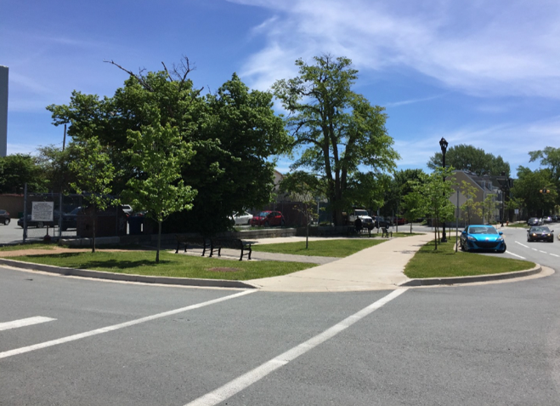
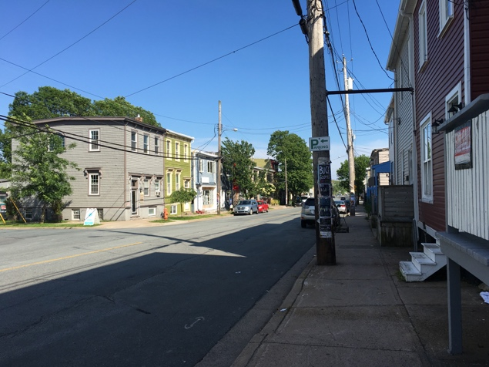
Figure 10. Agricola Street Sidewalks and the Set of Roundabouts.
The four potential curb extension areas are the intersections of West Street, Charles Street, North Street, and Bloomfield Street (Figure 11). a) West Street intersection is an ideal location for a bump-out, Belisha Beacons and crosswalk painting. It flows harmoniously from the commons heading north. It is by the hotel where guests can easily cross. b) Charles Street is another logical spot for curb extension. Bike racks are already located there. To improve pedestrians’ safety, curb extension and a higher level of visibility are required. c) North Street has an existing crosswalk, however, as Evans mentioned, a curb extension would impede traffic going towards the bridge (2017). It is possible to do a temporary bump-out, food patio with lanterns, or street arts at the north side there. d) Install curb extension at Bloomfield Street would prepare drivers coming into the area that they are entering a shared space environment.
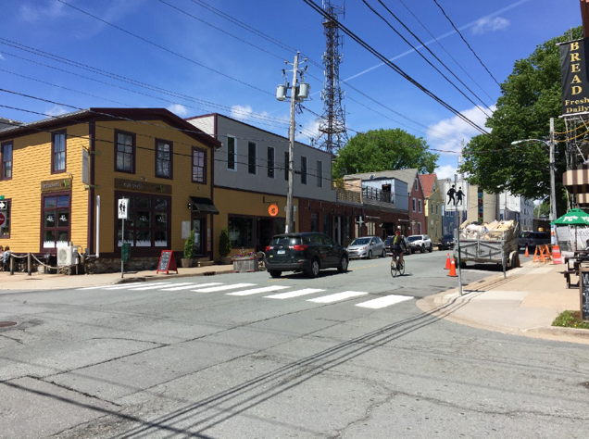
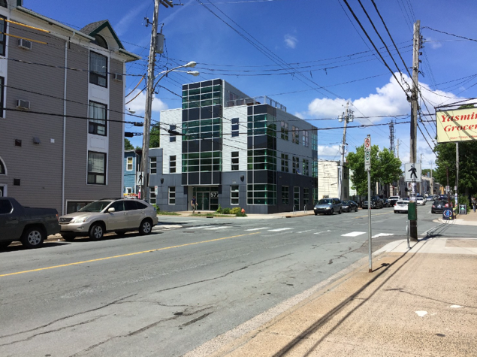
Figure 11. Four Potential Curb Extension spots on Agricola Street.
a) West Street b) Charles Street
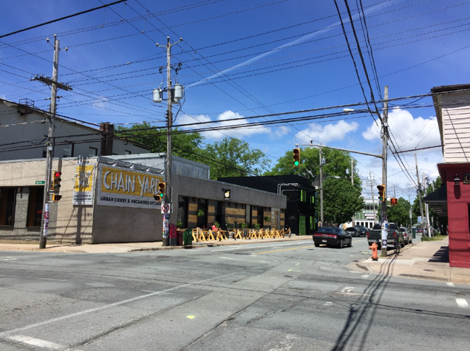
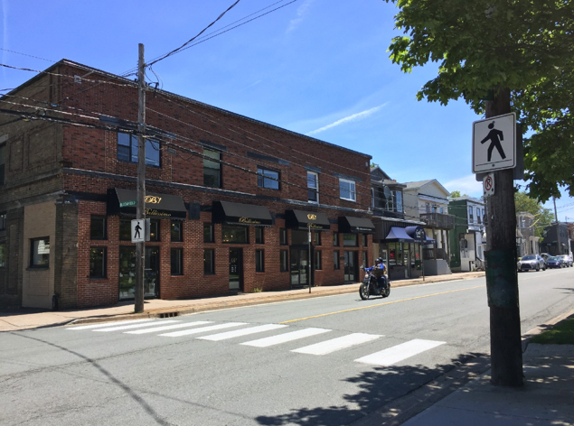
c) North Street d) Bloomfield Street
Participants in the Agricola Street workshop suggested street painting and street arts at the intersection of Harris and Sarah Street.
Considering the building heights, it is recommended to turn Agricola Street into a “valley”. Set Agricola Street as the centre line, the building heights can get higher towards its west bound and east bound. In this way, Agricola Street would be like a valley, and people are leaded visually into Agricola Street spontaneously by the buildings.

5. Young Street
S: Within the North End BID’s boundary, Young Street from Gottingen to Agricola Street is a connection between the BID and Hydrostone Market. There is a triangular green space along the street.
W: There is a sidewalk wall isolating the private property from the public property. It looks bald on the wide street with few to none vertical visual obstruction.
O: The sidewalk wall is long and facing to Young Street. The green space is large in area, with a bus stop.
T: It is a short part of street, so people may not attach importance to it. However, this area is a good gateway both for the North End BID and the Hydrostone Market.
Recommendations: The triangular green space could be utilized for activities and temporary events. It is recommended to install benches, tables, trees, arts, and wayfinding signs on the green space. Also, the sidewalk wall outside the brewery could be painted, or decorated in other ways, as a gateway sign to the area.

7. Almon Street
S: It is a commercial and residential street with many kinds of accessible services. At the intersection of Isleville Street, there is an apartment building whose shop windows and flower boxes blur the visual boundary between private and public spaces, and help to create an inviting and welcoming sidewalk (Figure 12). Ground-floor retail brings life to the street (Bousquet, 2017).
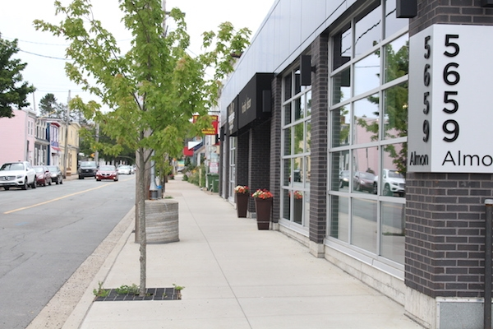
Figure 12. An apartment building on Almon Street. Image from: Halifax Examiner
W: Consider Almon Street as an “Established Residential” Street, Greenery is not enough (HRM 2017b). It looks bald and empty at the intersection of Gottingen Street. Little to none street furniture. Figure 13 shows a building built as a fortress, with an unwelcoming sidewalk wall.
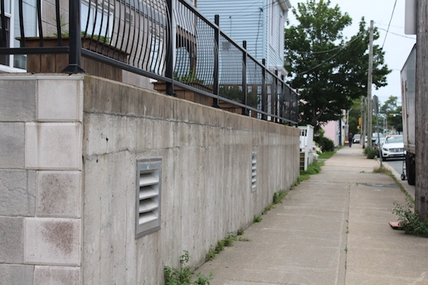
Figure 13. A building on the south side of Almon Street. Image from: Halifax Examiner
O: Almon Street is right in the middle of Agricola Corridor and Hydrostone Market. The intersections along the street are spacious.
T: Sidewalk is not wide. Lack of street identity.
Recommendations: Need more greenery. Street furniture such as benches and tables could be equipped along the “sidewalk wall” to blur it and bring life to the street. At intersections, set up wayfinding signage or street painting for Agricola Street corridor and Hydrostone Market. It would also gain street identity in this way.

8. Isleville Street
S: It is a mixed-use street with commercial and residential uses. When comes to the residential area (from Bilby to Russell Street), green space is getting more.
W: It seems empty around the parking lot.
O: The land between Almon and Bilby Street on Isleville Street is a large parking lot with two intersections nearby.
T: Residential buildings are close to the parking lot, residents may not want to hear noise from the proposed events. Lack of street identity.
Recommendations: The parking lot could be used to hold temporary street markets or other engaging activities. Artistic street painting at the two intersections would attract more people to the place. Intersection painting itself could also be hold as an event. For future development, building heights from Young to Bloomfield Street could have a downward trend, visually leading people to the commercial centre at Agricola Street.

9. Maynard Street
S: It is a long street with residential houses and independent businesses. Sidewalk is wide and green, with a soft boundary between public and private property (Figure 14).
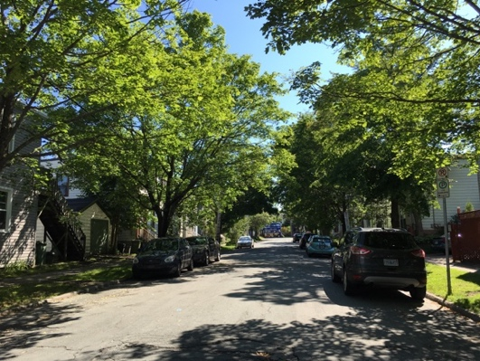
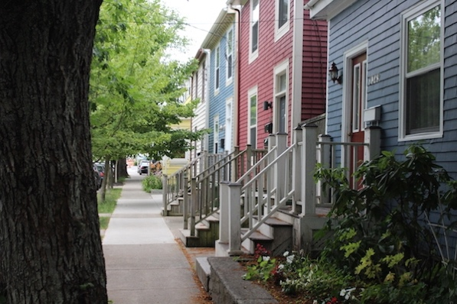
Figure 14. An apartment building on Maynard Street.
W: Outside of the apartment building, the border between private and public spaces is clearly demarcated, and walking along the building provides no visual breaks (Figure 15).
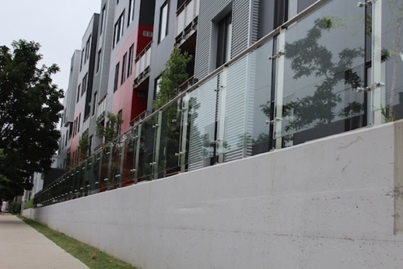
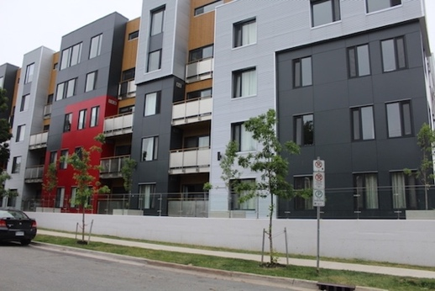
Figure 15. A building on Maynard Street. Image from: Halifax Examiner

As shown in Figure 16, the building is going for a sort of industrial style. The buildings are in the neighbourhood but not part of the neighbourhood. The residents of the new buildings are walled off from their neighbours. Bousquet says that the implicit message is that people out there are dangerous (Bousquet, 2017). In a racially diverse neighbourhood like this, the symbolism is unhealthy.
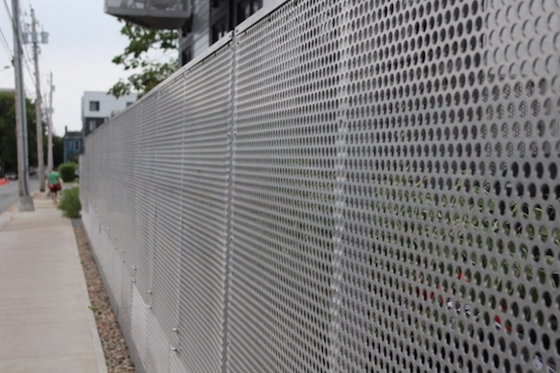
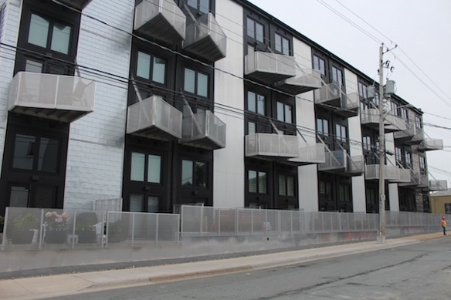
Figure 16. A building on Maynard Street. Image from: Halifax Examiner
O: There is a small open space at the end of West Street on Maynard Street. Sidewalk is not narrow.
T: As a street with several independent businesses, Maynard Street is too quiet with little promotion. As shown in Figure 17, the sidewalk next to the Armoury is not clean, which might affect people’s interest and impression of the street.
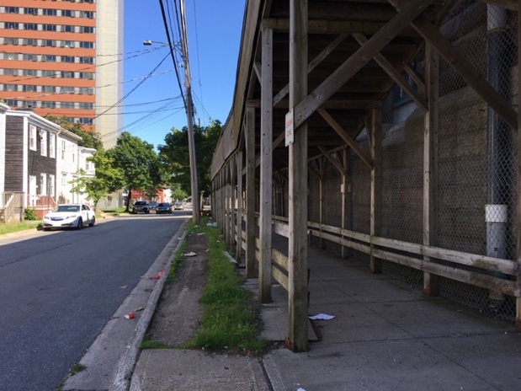
Figure 17. The sidewalk of the Armoury on Maynard Street.
Recommendations: The sidewalk boundary could be softened by implementing street furniture or paintings. At the small open space where West Street ends, it is recommended to have a street sign or planters to show the street character.

11. Bauer Street
S: There is an attractive transition from private to public spaces on Bauer Street (Figure 18). There are certainly property lines, however, no clear visible delineation from the household to the sidewalk (Bousquet, 2017). “A resident might be tending the gardens along the street; a neighbour could sit on the porch to talk” (Bousquet, 2017).
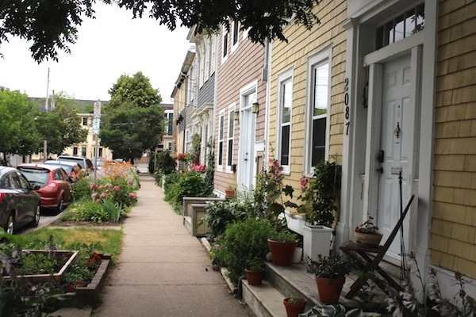
Figure 18. Residential buildings on Bauer Street. Image from: Halifax Examiner
W: There are only few people know such a beautiful street.
O: Bauer Street could be a good site for students to visit and learn about an inviting residential street. There is a downward-slope street—Falkland Street that leads to Gottingen Street.
T: It might seem a little isolated from the main streets such as Gottingen Street.
Recommendation: Promote the street. Set Bauer Street as a learning example, to encourage this kind of residential street typology. Considering the downward slope, there could be a wayfinding sign at the intersection of Falkland Street.

20. Bloomfield Street
S: It is a quiet, lush and green residential street with only three independent businesses. The Streetscape is upward from Gottingen/Agricola, then downward to Agricola/Gottingen. The greenery attracts people to walk about on the street, then leading them to another commercial street. Colourful houses make the street more alive (Figure 19).
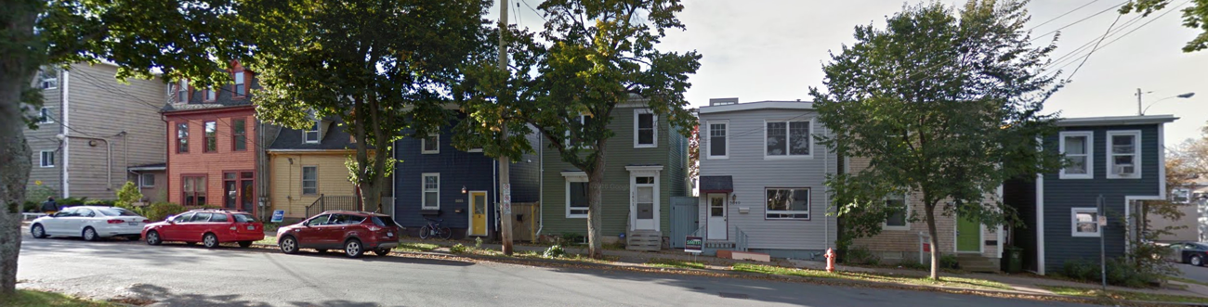
Figure 19. Residential buildings on Bloomfield Street. Image from: Google Map
W: Not very clean. The independent business—The Bridge is inconspicuous on the street, which is not good for its development.
O: The Bridge building façade and outside has space to advertise.
T: Few people know there are independent businesses on the street.
Recommendations: The Bridge could have signs or logo outside the building to attract more customers.

21. Fuller Terrace
S: Sidewalk is wide with colourful houses and well-placed greenery. It is a beautiful and quiet residential street (Figure 20). The view to Bloomfield Street is great. Private and public properties are blurred by plants.
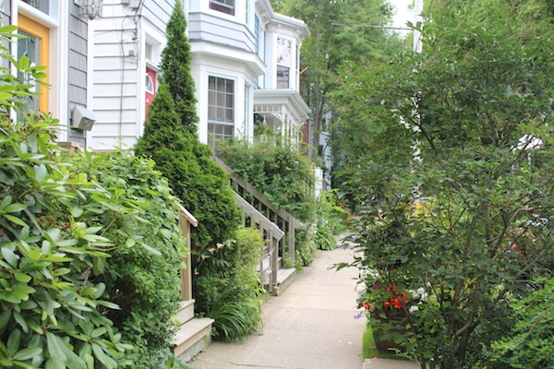
Figure 20. Residential buildings on Fuller Terrace. Image from: Halifax Examine
W: Residential streets are not that clean (Figure 21). There are personal garbage cans along the street, but no public ones.
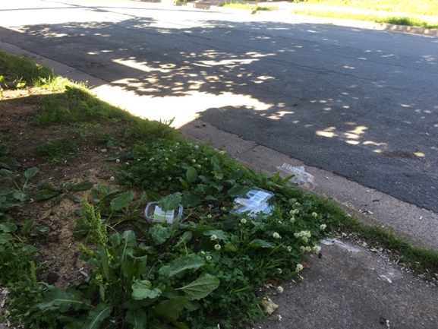
Figure 21. Garbage on Fuller Terrace.
O: There is at least one personal garbage can in front of each house.
T: Lack of Street identity.
Recommendations: To organize residents to paint on their garbage cans is a good way to gather people together, make the neighbourhood busy, and show street identity.

26. Bilby Street
S: The street block from Isleville to Agricola Street is green, quiet, and beautiful.
W: It looks empty along the street block from Gottingen to Isleville Street.
O: There are 2 big parking lots along the street from Gottingen to Isleville Street and the streetscape is an upward slope (Figure 22).
T: Residential buildings are close to the parking lots, residents may not want to hear noise from the proposed events. Lack of street identity.
Recommendations: One of the parking lots is at the highest geographic point on the street. Utilize the parking lot to host events and festivals to attract people and increase street identity.
Figure 22. Parking lot on Bilby Street. Image from: Google Map
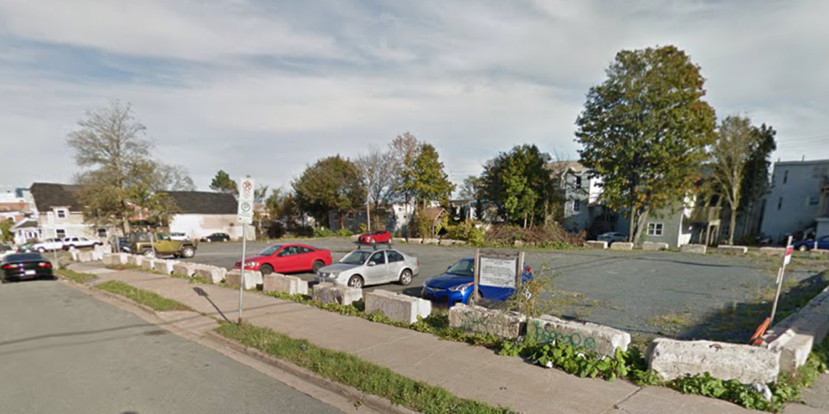

Conclusion
The streetscape report was borne out of recommendations set forth in Improving Halifax North End: The Centre Plan and the Integrated Mobility Plan. The report is predicated on incremental change, and draws much of its strengths, weaknesses, opportunities, and Threats. The guidelines, recommendations and conceptual ideas prepared for the report draw on input that the study received throughout the project. It is hoped that the report will provide an enhancement strategy for the streetscapes of North End BID that reflects the community and its diverse identity, and will breathe new life into the public realm.

References
Bousquet, T. (2017). Stop the Johannesburgization of Halifax’s north end. Halifax Examiner. Retrieved from: https://www.halifaxexaminer.ca/city-hall/stop-the-johannesburgization-of-halifaxs-north-end.

Bundale, B. (2012). Downtown Halifax commercial assessments soaring. The Chronicle Herald. Retrieved from http://thechronicleherald.ca/business/65190-downtown-halifax-commercial-assessments-soaring?utm_source.

Ecoplans, a member of the MMM Group Limited. (2012). Re-Imaging Cardinal: The Village Streetscape Plan. Retrieved from: http://www.twpec.ca/wp-content/uploads/2014/03/Cardinal-Streetscape-Plan-Full-Document-June-25-2012.pdf.

Evans, F. (2017). Agricola Street Enhancement working notes. Retrieved from: https://drive.google.com/file/d/0BzwirXpB6w91RzlaYUlCTkRzNHhDaUFrWHE2OTR5MHJlTDZB/view?usp=sharing

Halifax Regional Municipality. (2014a). 5 Year, $50 Million Capital Improvement Campaign Council Report. Retrieved from: https://drive.google.com/file/d/0BzwirXpB6w91SHNBcTBxY18taDhKaVlIZUZoOTk2dGlSbkNj/view?usp=sharing

Halifax Regional Municipality. (2014b). Making Connections: 2014-2019 Halifax Active Transportation Priorities Plan. Retrieved from: https://www.halifax.ca/sites/default/files/documents/transportation/transportation-projects/AT_Plan_Final_July222014_000.pdf

Halifax Regional Municipality. (2017a). Transportation planning: Integrated Mobility Plan. Retrieved from: https://www.halifax.ca/about-halifax/regional-community-planning/transportation-planning.

Halifax Regional Municipality. (2017b). Centre Plan 2017. Retrieved from: https://www.centreplan.ca.

North End Business Association. (2017). Halifax’s historical North End. Retrieved from: http://gonorthhalifax.ca/about.

Roth, N. (2013). North End Halifax in transition: a current examination of chance and redevelopment on Gottingen Street. Retrieved from: http://theoryandpractice.planning.dal.ca/_pdf/neighbourhood_change/mplan_projects/nathanroth_thesis.pdf.

San Francisco Planning Department. (2010). San Francisco Better Streets Plan Policies and Guidelines for the Pedestrian Realm. Retrieved from: http://www.sf-planning.org/ftp/BetterStreets/docs/FINAL_4_Street_Types.pdf.

Statistics Canada. (2012). Focus on Geography Series, 2011 Census. Statistics Canada Catalogue no. 98-310-XWE2011004. Ottawa, Ontario. Analytical products, 2011 Census.

Appendix A – Drawings for Street Typologies
Commercial Street Typology
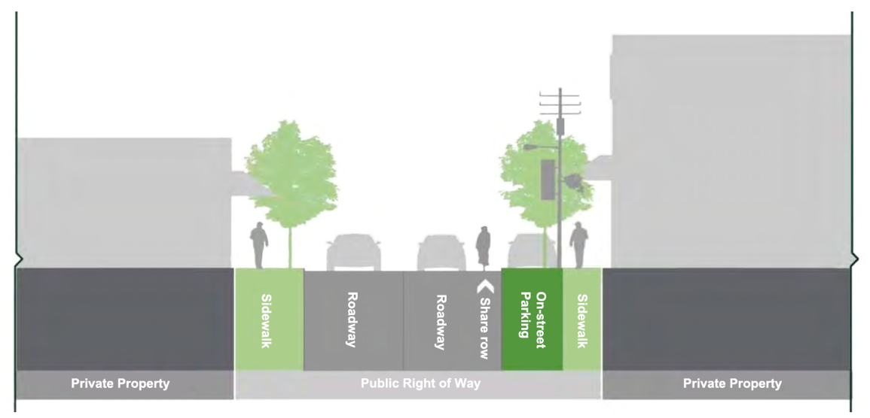

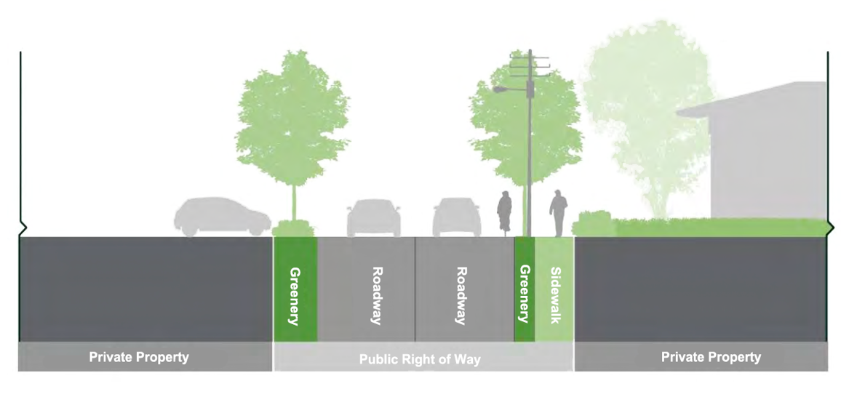
Industrial Street Typology
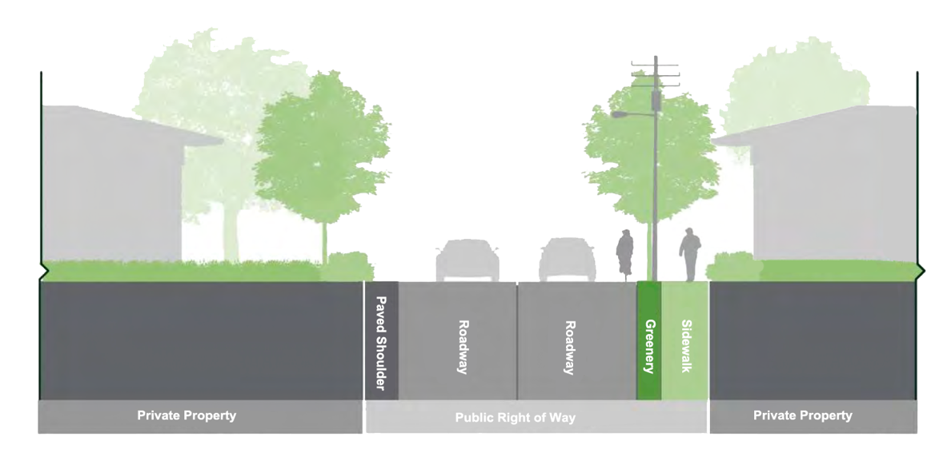
Residential Street Typology

(Ecoplans, a member of the MMM Group Limited, 2012)

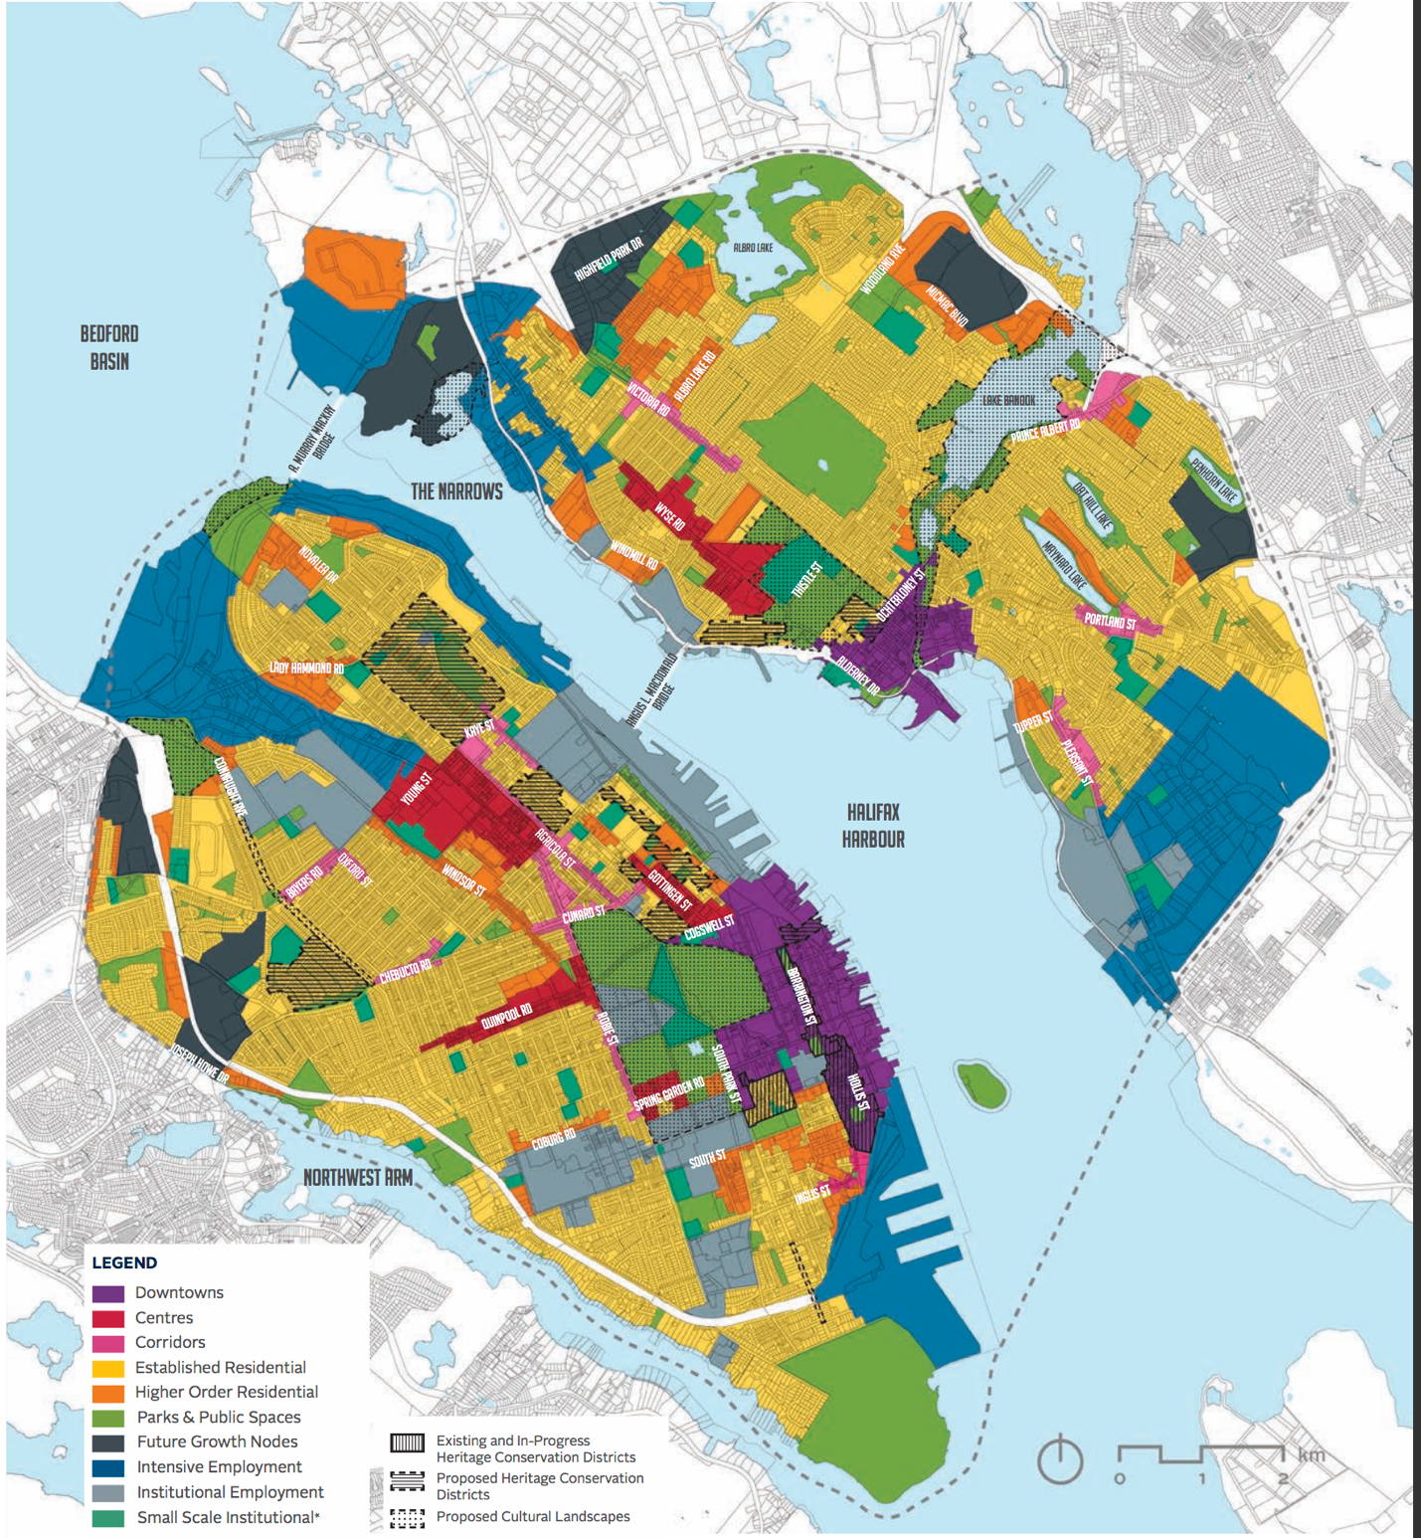
Appendix B – Urban Structure Map in 2017 Centre Plan

(HRM, 2017b)

